**OCW Assignment -6 NAME: A. INTHRA KUMAR**

**ROLL NO: S20220010085**

**QN 1:**

Write a shell script to accept a lucky number as an input from the user and if the input is 888 then print a message as you are the “first winner”, if it is 999 then print that you are the “second winner”, otherwise print as try for the next time.

**CODE:**

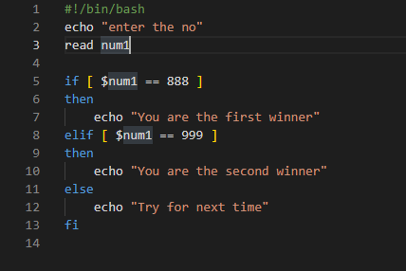

**OUTPUT:**

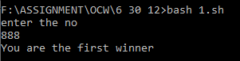

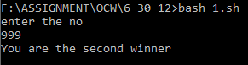

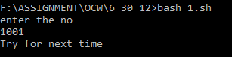

**QN2:**

Write a shell script to accept your date of birth as a 3 input number from the user in the form of date, month and year. Check whether the addition of these three numbers is even or odd and print the respective message.

**CODE:**

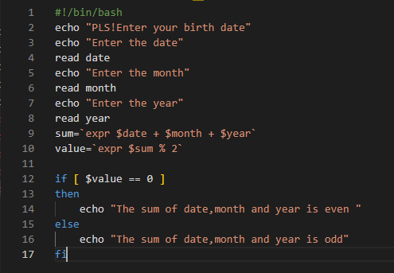

**OUTPUT:**

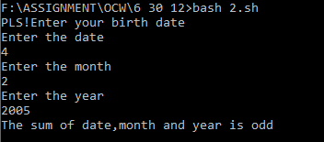

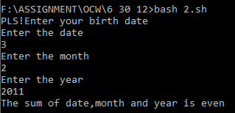

**QN3:**

Write a shell script to display the summation of all even numbers between 1 to 20.

**CODE:**

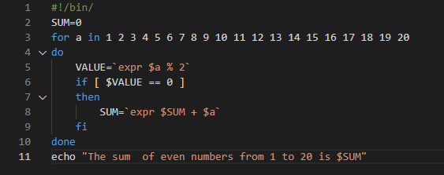

**OUTPUT:**

